***DESIGN AND ANALYSIS OF ALGORITHMS PROJECT***

**MEMBERS :-**

* SHARJEEL SAFDAR (22K4210)
* UZAIR AHMED KHAN (22K4189)
* SUHAIB SHAIKH (22K4302)

**QUESTION 2)**

import random

import math

import os

def karatsuba(x, y):

if x < 10 or y < 10:

return x * y

num_digits = max(len(str(x)), len(str(y)))

split = num_digits // 2

high1, low1 = divmod(x, 10 ** split)

high2, low2 = divmod(y, 10 ** split)

z0 = karatsuba(low1, low2)

z1 = karatsuba(low1 + high1, low2 + high2)

z2 = karatsuba(high1, high2)

result = z2 * 10 ** (2 * split) + (z1 - z2 - z0) * 10 ** split + z0

return result

def calc_distance(p1, p2):

return math.sqrt((p1[0] - p2[0])**2 + (p1[1] - p2[1])**2)

def closest_pair(points):

points.sort(key=lambda p: p[0])

def recursive_find(points):

if len(points) <= 3:

return brute_force(points)

mid = len(points) // 2

left = points[:mid]

right = points[mid:]

dist_left, p1_left, p2_left = recursive_find(left)

dist_right, p1_right, p2_right = recursive_find(right)

min_dist = min(dist_left, dist_right)

closest_pair = (p1_left, p2_left) if min_dist == dist_left else (p1_right, p2_right)

cross_dist, cross_p1, cross_p2 = merge_check(points, points[mid], min_dist)

if cross_dist < min_dist:

return cross_dist, cross_p1, cross_p2

else:

return min_dist, closest_pair[0], closest_pair[1]

return recursive_find(points)

def brute_force(points):

min_dist = float('inf')

closest_pair = (None, None)

for i in range(len(points)):

for j in range(i + 1, len(points)):

dist = calc_distance(points[i], points[j])

if dist < min_dist:

min_dist = dist

closest_pair = (points[i], points[j])

return min_dist, closest_pair[0], closest_pair[1]

def merge_check(points, mid_point, min_dist):

strip = [p for p in points if abs(p[0] - mid_point[0]) < min_dist]

strip.sort(key=lambda p: p[1])

min_dist_across = min_dist

best_pair = (None, None)

for i in range(len(strip)):

for j in range(i + 1, len(strip)):

if (strip[j][1] - strip[i][1]) >= min_dist_across:

break

dist = calc_distance(strip[i], strip[j])

if dist < min_dist_across:

min_dist_across = dist

best_pair = (strip[i], strip[j])

return min_dist_across, best_pair[0], best_pair[1]

def generate_closest_pair_data(file_name, num_points):

points = [(random.randint(0, 1000), random.randint(0, 1000)) for _ in range(num_points)]

if os.path.exists(file_name):

os.remove(file_name)

with open(file_name, 'w') as file:

for point in points:

file.write(f"{point[0]} {point[1]}\n")

def generate_multiplication_data(file_name, num_tests):

if os.path.exists(file_name):

os.remove(file_name)

with open(file_name, 'w') as file:

for _ in range(num_tests):

x = random.randint(10 * (num_tests - 1), 10 * num_tests - 1)

y = random.randint(10 * (num_tests - 1), 10 * num_tests - 1)

file.write(f"{x} {y}\n")

for i in range(10):

generate_closest_pair_data(f"closest_pair_input_{i+1}.txt", 200)

generate_multiplication_data(f"int_multiplication_input_{i+1}.txt", 5)

**QUESTION 3)**

def apply_closest_pair(file_name):

points = []

with open(file_name, 'r') as file:

for line in file:

x, y = map(int, line.strip().split())

points.append((x, y))

dist, p1, p2 = closest_pair(points)

print(f"Closest pair in {file_name}: {p1}, {p2} with distance {dist}")

def apply_karatsuba(file_name):

with open(file_name, 'r') as file:

for line in file:

x, y = map(int, line.strip().split())

result = karatsuba(x, y)

print(f"Multiplication result for {x} * {y}: {result}")

for i in range(10):

apply_closest_pair(f"closest_pair_input_{i+1}.txt")

apply_karatsuba(f"int_multiplication_input_{i+1}.txt")

**OUTPUT:-**

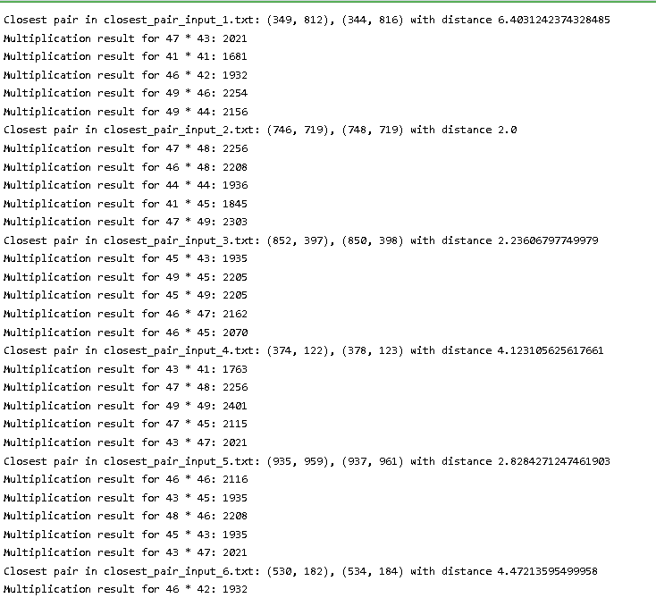

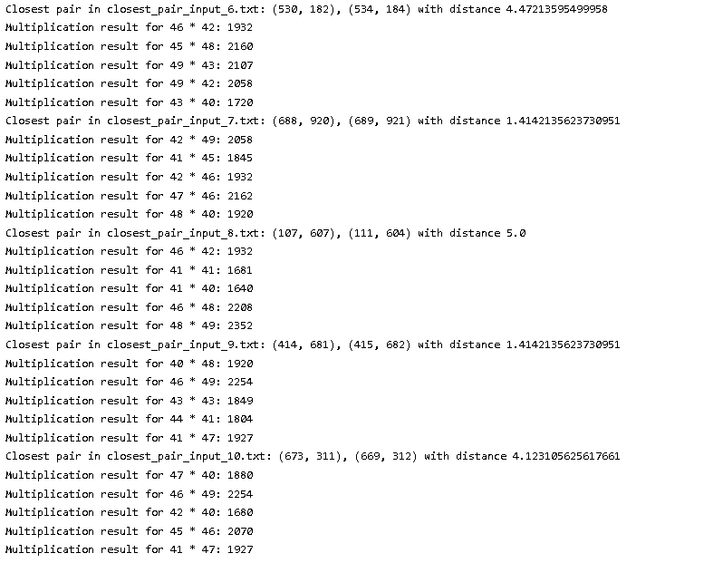

**QUESTION 3)**

GUI : Streamlit

LANGUAGE : Python

IDE : Visual Studio

STEP 1 :-

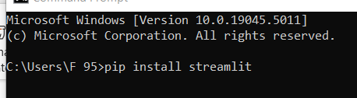

STEP 2 :-

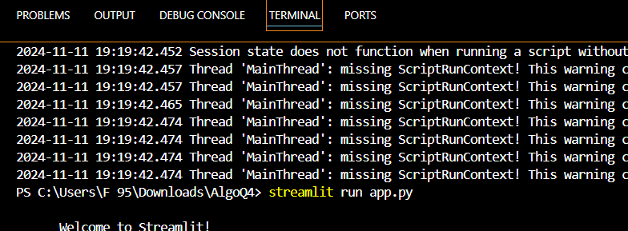

STEP 3 :-

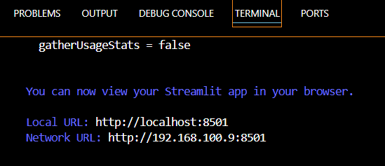

STEP 4 :-



STEP 5 :-



STEP 6 :-

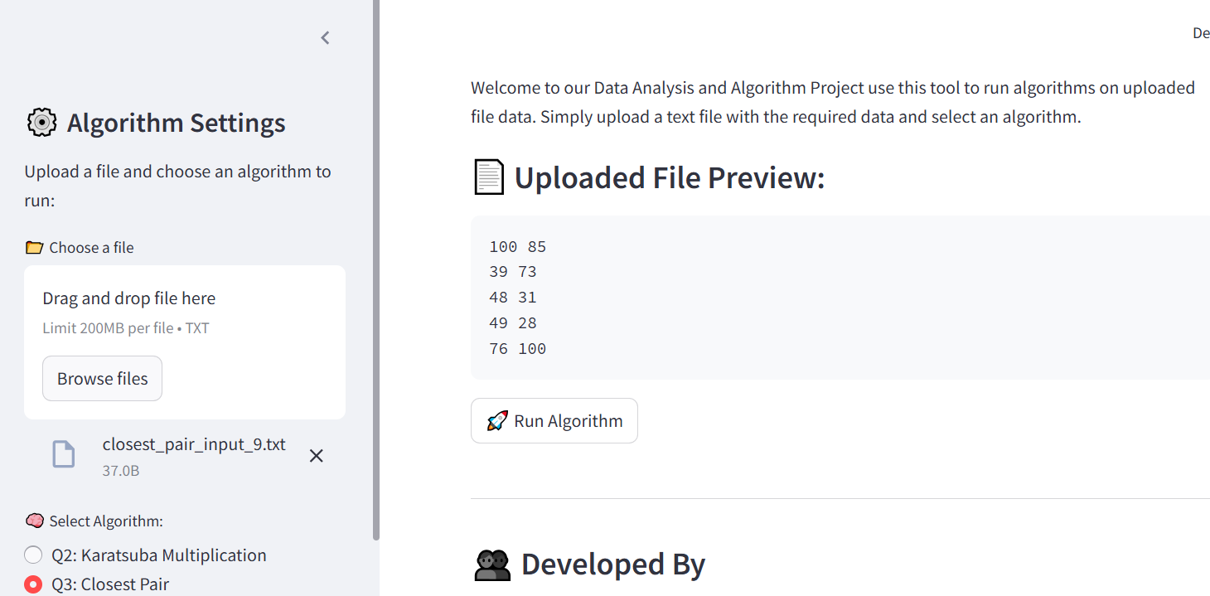

STEP 7 :-



STEP 8 :-

